Context Free Application Development Plan

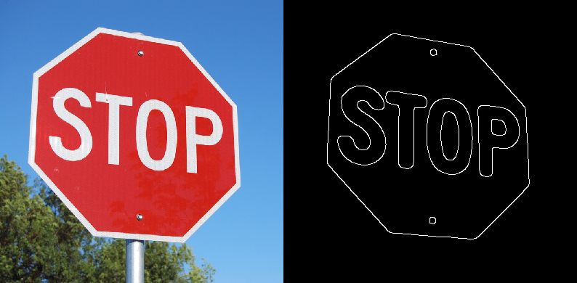

Figure 1: Canny Edge Detection run on a blurred version of (Red – (Green + Blue)) channel subtraction.

# Team

* Team name: Context Free
* Team members: Kevin Cherry, Robert Firth, Dennis Castleberry

# Requirements

* **Main goal**: to minimize the likelihood of pedestrian and driver casualties due to inaccuracies and inefficiencies in sign, crosswalk, and pedestrian detection algorithms.

To accomplish this, we propose implementing three algorithms for stop sign detection – one implementation of SURF and two new faster algorithms specifically devised for the task of fast stop sign detection. This algorithms are listed below as objectives.

* **Supplementary goals, objectives, and tasks**:
  1. **Goal**: stop sign detection. Detect stop signs in real-time with sufficient efficiency to allow for stopping time. Test SURF against two alternate algorithms, described below.
     1. **Objective**: construct an R-channel integral-image-based detector.
        1. **Task**: compute integral image on the R-channel of the image.
        2. **Task**: superimpose an*m*x*m*grid on the image and compute the sums of the R-channel intensity per 2x2 region.
        3. **Task**: for the 2x2 region with the maximum sum, recursively apply (ii) until the region with the maximum R-channel intensity density is obtained.
        4. **Task**: in the neighborhoods of the vertices inside the maximum-density region, find the four box such that the diagonal along those boxes separates a maximum-density R-channel triangle from a minimum-density R-channel triangle.
        5. **Task**: obtain the 8 vertices of the sign from the above.
     2. **Objective**: construct octagon detector.
        + **Task**: apply a shape detector to yield sets of vertices.
        + **Task**: discard all sets where *n*6= 8.
        + **Task**: check to see if the opposing edges of the 8-vertex shape are parallel (within a certain threshold).
  2. **Goal**: pedestrian crosswalk sign detection.
     1. **Objective**: construct and RG-channel integral-image-based detector.
        1. **Task**: compute integral image on the R-channel of the image.
        2. **Task**: superimpose an*m*x*m*grid on the image and compute the sums of the R-channel intensity per 2x2 region.
        3. **Task**: for the 2x2 region with the maximum sum, recursively apply (ii) until the region with the maximum R-channel intensity density is obtained.
        4. **Task**: in the neighborhoods of the vertices inside the maximum-density region, find the two boxes such that the diagonal along those boxes separates a maximum-density RG-channel triangle from a minimum-density RG-channel triangle.
        5. **Task**: obtain the 3 vertices of the sign from the above.

# Design

* Classes in namespace OMS.CV SURFStopSignDetector, StopSignDetectorA, StopSignDetectorB are concrete implementations of the StopSignDetector class. Likewise, PedDetectorA is an implementation of the abstract PedDetector class. Both StopSignDetector and PedDetector are subclasses of Detector.
* **Modules** 
  1. **OMS.CV.SURFStopSignDetector**
     1. **Functionalities:** Implementation of a stop sign detector using a SURF implementation provided by EmguCV.
        + **Also using classes** OMS.CV.Detector, OMS.CV.StopSignDetector, OMS.CV.StopSignDetectorA
  2. **OMS.CV.StopSignDetectorA**:
     1. **Functionalities**: computes and uses integral image on the R-channel to find maximum density areas used to approximate the region occupied by the stop sign.
     2. **Data structures**:
        + **Namespaces**: EmguCV.CV.
        + **Classes** (Image) and **class members**: Resize(), Convert(),
        + **Also using classes** OMS.CV.Detector, OMS.CV.StopSignDetector, OMS.CV.StopSignDetectorA
  3. **OMS.CV.StopSignDetectorB**:
     1. **Functionalities**: uses edge detection, then isolates eight vertices with maximum octagonality.
     2. **Data structures**: Image, LineSegment2D, boxList, triangleList, Contour
        + **Namespaces**: EmguCV.CV.
        + **Classes** (Image, Contour) and **class members**: Canny(), HoughLinesBinary(), Resize(), Convert(), PyrUp(), PyrDown(), FindContours().
        + **Also using classes** OMS.CV.Detector, OMS.CV.StopSignDetector, OMS.CV.StopSignDetectorB
  4. **OMS.CV.PedDetectorA**:
     1. **Functionalities**: detects pedestrians using built-in EmguCV classes.
     2. **Data structures**: Rectangle[].
        + **Namespaces**: EmguCV.CV.
        + **Classes** (Image, HOGDescriptor) and **class members**: Draw(), SetSVMDetector(), DetectMultiScale(), GetDefaultPeopleDetector().
        + **Also using classes** OMS.CV.Detector, OMS.CV.PedDetector, OMS.CV.PedDetectorA

# Data

We will capture video from areas dense in pedestrian crosswalk and child crossing signs in a variety of weather conditions (normal weather, nighttime, light and heavy rain); then segment the video to isolate the target objects. We require two data sets; one to explore existing implementations and make incremental improvements, and a second to test the improved implementation.

# Implementation Plan and Timeline

# User Interface

• **Mod**

# 

# Appendix

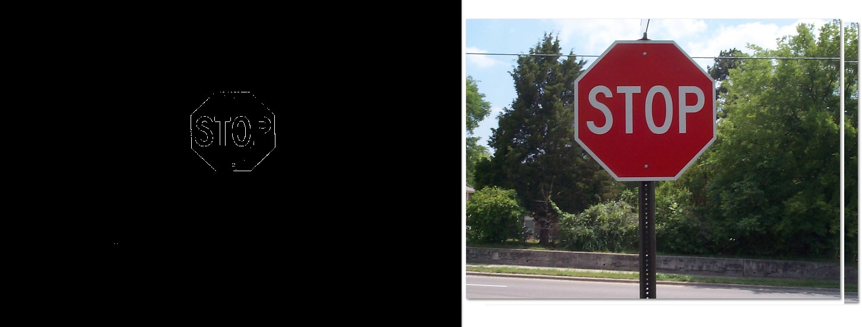

Figure 2: Edge detector by computing R-(G+B), clamped from 0 to 255

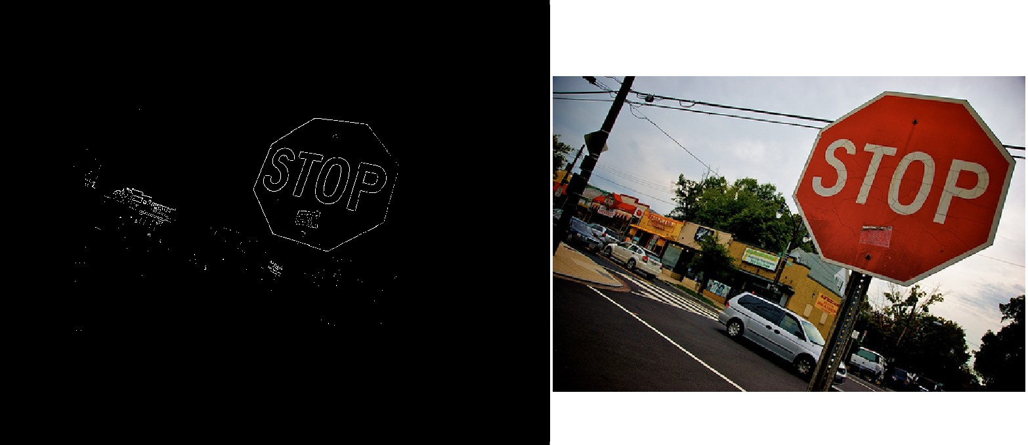

Figure 3: Edge detector by computing R-(G+B), clamped from 0 to 255